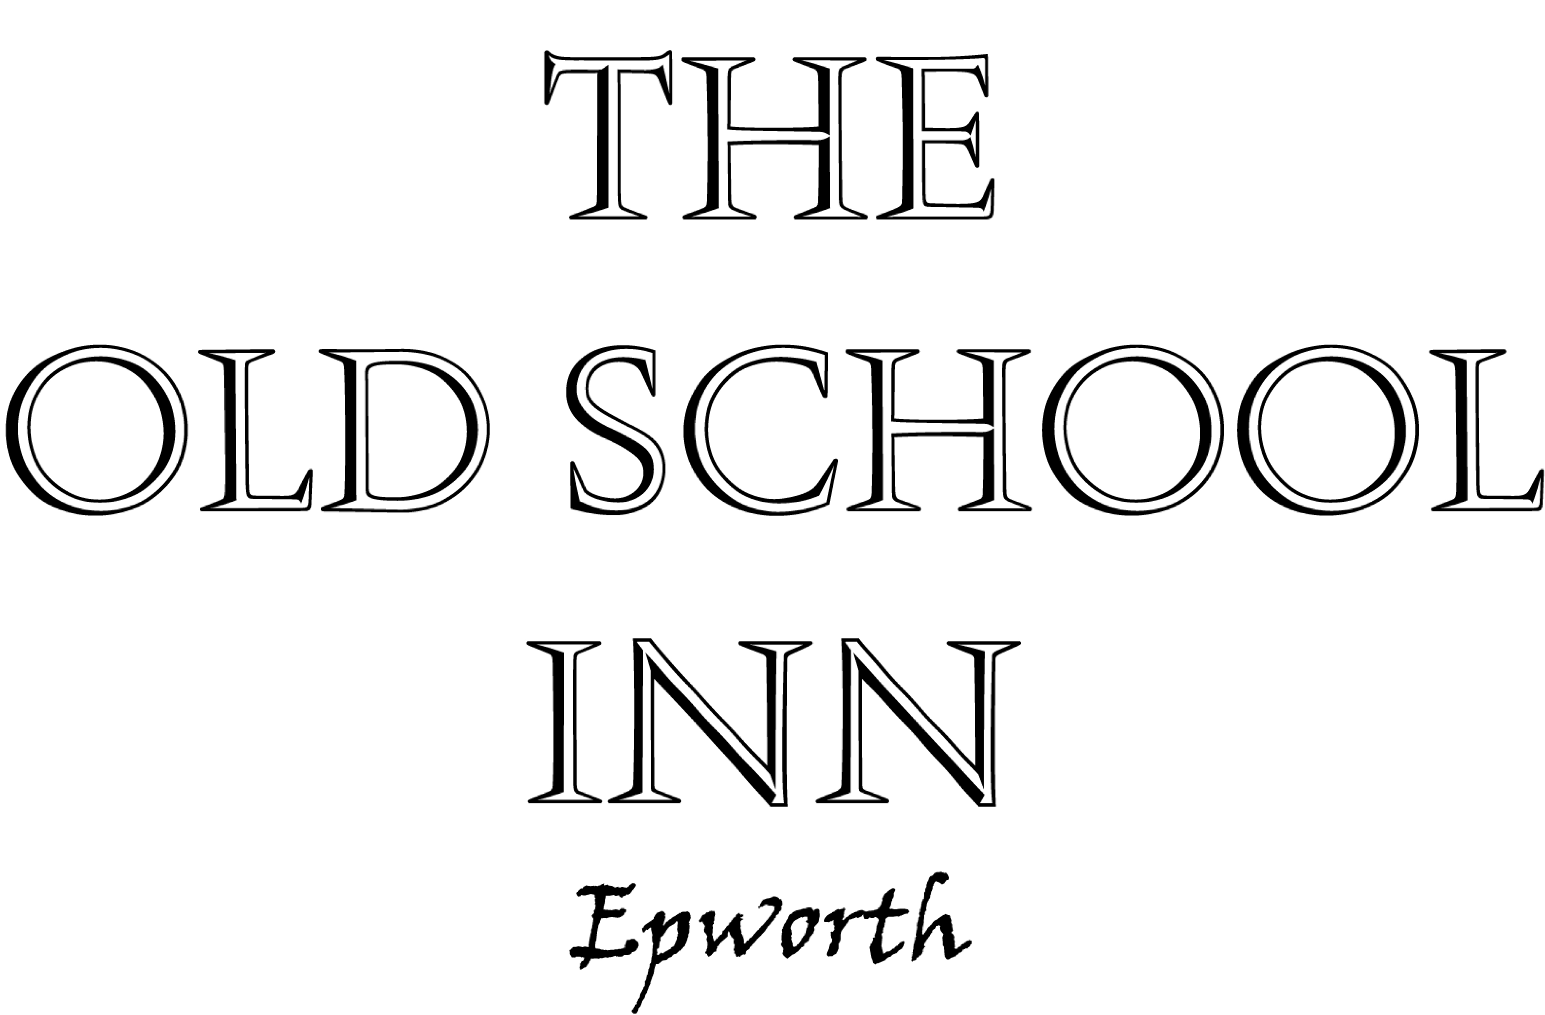

Little Ones Menu*

Mains - £4.50

Chicken Nuggets
Homemade nuggets in breadcrumbs & skinny fries
With either; mixed steamed vegetables, beans or salad.
Fish Goujons
Battered haddock Goujons with skinny fries or home- made chips
With either; mixed steamed vegetables, beans or salad.
Penne Bolognese
With or without cheese.
Penne in a Tomato or basil pesto sauce (V)
With or without cheese.
Mini Burger
With or without cheese, skinny fries & mini salad.

Desserts

Ice cream Sundae chocolate brownie, chocolate ice cream, chocolate sauce £3.50
Homemade chocolate brownie with vanilla or chocolate ice-cream £2.50
Sticky Toffee pudding with vanilla or chocolate ice-cream £2.50
Ice-cream (please ask for flavours) £2.50

* Menu for under 12’s only.
Thank you.

All our food is prepared on a daily basis. (V) Vegetarian dishes please ask staff to discuss options with the kitchen if alternative vegetarian dishes are required Our kitchen does store products that do contain both nuts and dairy; if you are unsure on any items please feel free to ask a member of staff. If you have any diagnosed food allergies please inform staff on time of arrival, Thank you.

